Differential Privacy Lab

Use the given PowerPoint and notes for information regarding Differential Privacy

First, find or create a dataset that is the results of a survey of a yes or no question.

Next, apply the randomized algorithm described in the notes to the dataset, for example the coin flip scenario. Put the new results into a new dataset. A diagram for the algorithm is supplied below.

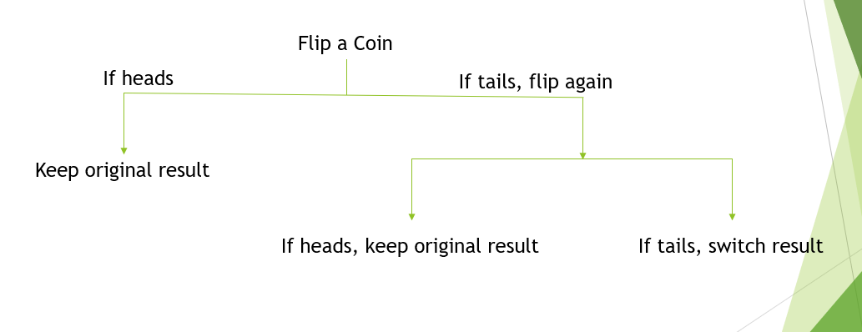

Compare the results of the original and the new dataset. Use matplotlib library in python to plot the results.

Now, change the size of the original dataset and see what happens. If you increase the size, is there more or less variance? Create a text output in your program with the answer